Older Adult’s Mental Health Workshop for
South Asian Elders and their Carers

Tuesday 30 April, 10.30am – 12.00pm
Sikh Leisure Centre, Prospect St, Huddersfield HD1 2NX





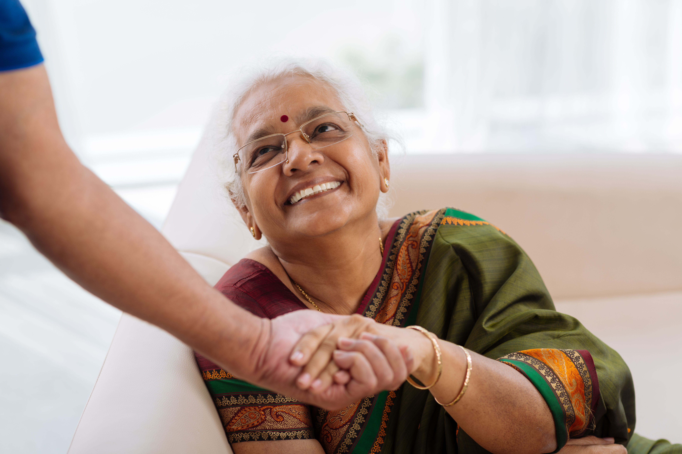

The way we provide
older adult’s mental health is changing
We are improving our services to make sure they continue to meet people’s needs and offer the best care and outcomes for our service users. We have listened to what service users, carers, partners and staff have told us so far and we would like to talk to you about our ideas for improvement.

As part of our ongoing engagement we are keen to meet with people from different groups. On Tuesday 30 April we are holding a workshop and are especially keen to engage with older adults from the South Asian community and with family members / carers of someone with mental health issues.

If you would like join us to discuss please book a place by
calling 07867 787409 or email yasmin.arshad@swyt.nhs.uk
Refreshments will be provided and travel expenses can be
claimed back.

